User Guide 39 Guest access to SPEAR applications
Purpose of this User Guide
The purpose of this User Guide is to provide guidance to Applicant Contacts on how to grant and remove guest access to SPEAR applications.
Who should read this?
Primary audience: All SPEAR users and members of the public such as property owners, land developers and any other interested third parties.
Introduction
SPEAR is an online system that enables Subdivision Act plans to be electronically submitted to the Responsible Authority, referred to referral authorities and tracked online from the initial planning stage through to certification and issuing of Statement of Compliance (SOC). As such, the main components of SPEAR are only accessible to surveyors (Applicant Contact), Responsible Authorities, referral authorities, Land Use Victoria and public objectors.
Applicant Contacts can grant guest access to third parties to login to SPEAR on an application-by-application basis. Whilst the guest cannot upload or modify any documents in SPEAR, they will have access to every document within that application, including those added by Responsible Authorities and RAs. Guest access allows a guest user to:
- View, save or print documents
- Pay fees to the responsible authority (where SPEAR Payments have been enabled) and receive SPEAR notification emails when applications reach key milestones - Planning Permit Decision, Street Addressing completed, Certification Decision, SOC Decision, Release for Lodgment, Lodgment at Land Use Victoria, Registration at Land Use Victoria.
This guide outlines the processes involved in granting and removing guest access.

39.1 How do I invite a guest to view my SPEAR application?
- Click on the Guests tab within the chosen application and type in the email address of any guests you would like to invite. You will also need to select or enter a reason for inviting each guest and click ‘invite’.

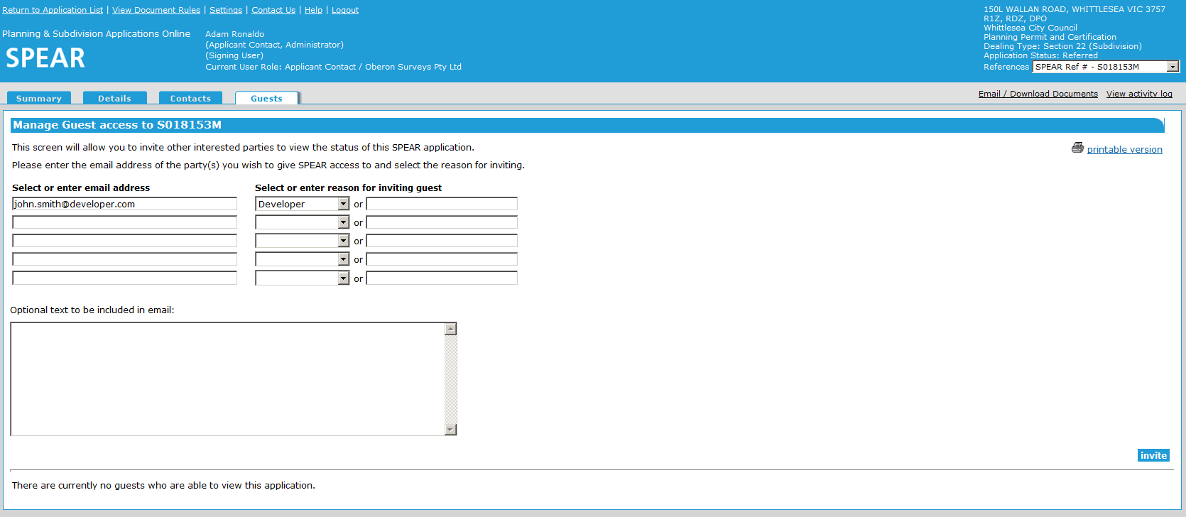

- SPEAR will automatically send an email to each guest containing a SPEAR guest user ID and password. The guest will be able to login to SPEAR to view the application and print or save all associated documents.

39.2 How do I remove a guest from my SPEAR application?
- Click on the Guests tab within the chosen application. Tick the checkbox next to each guest you would like to remove and click ‘remove’.
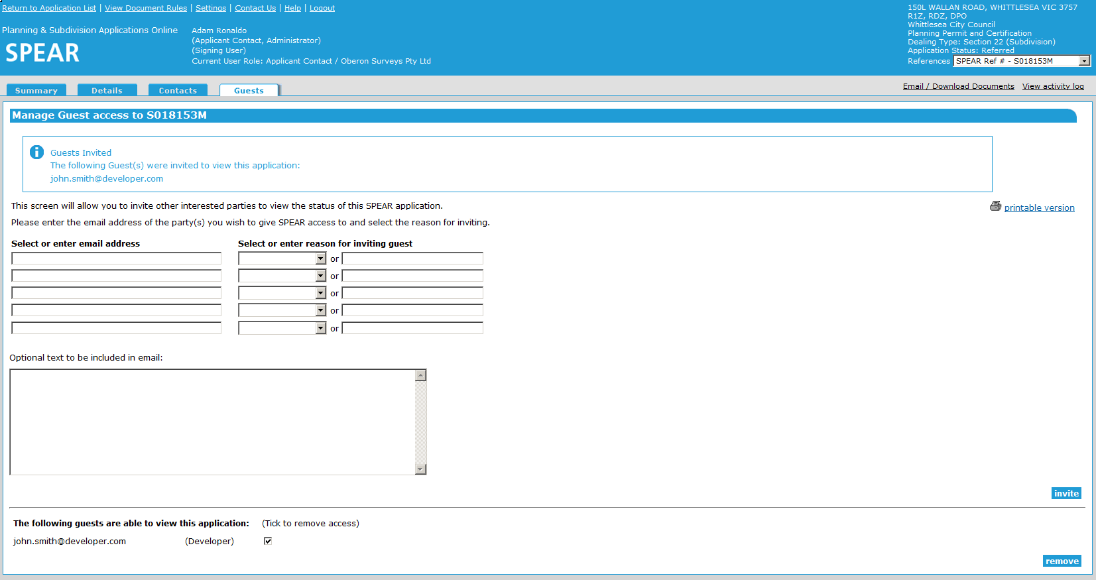

39.3 How do I remove a guest from multiple SPEAR applications?
Applicant Contacts can remove a guest from multiple SPEAR applications at once. This option only becomes available once a guest has been invited to view an application.
- Browse to the Application List and click the Remove Guests link (located at the very top of the screen. This link will only be visible once you have invited at least one guest to an application.
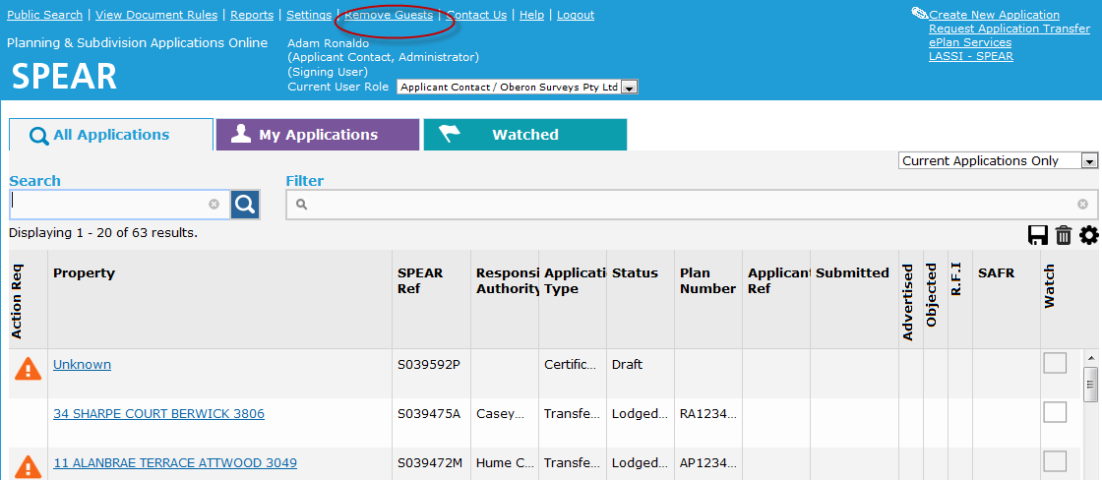

- Tick the checkbox next to each application from which you wish to remove guest access and click ‘remove’.
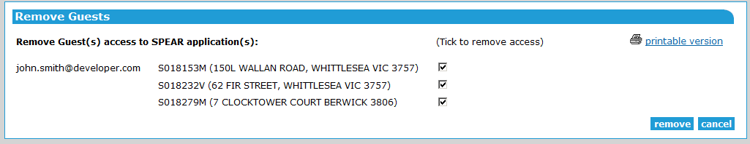

39.4 Can Responsible Authorities of RAs invite guests to view applications?
Responsible Authorities and referral authority users are unable to invite guests to view applications. However, these users will be able to view a list of guests that have been invited by the Applicant Contact to view a particular application by clicking on the Guests tab within that application.
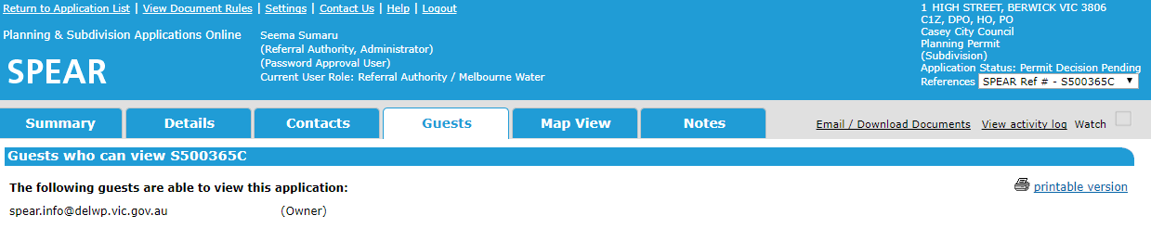

39.5 When will guest access to an application expire?
For a planning permit-only application, guest access will expire sixty days after a permit decision has been made.
If the application involves a certification component, guest access will expire once the application has reached a status of ‘Lodged at Land Use Victoria’.
Once these milestones have been reached, guests will no longer be able to view the application, and the Applicant Contact will be unable to invite additional guests.
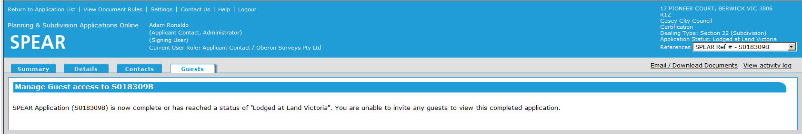

Need more information?
Further information on this topic can be found by:
- Visiting the SPEAR website www.spear.land.vic.gov.au/SPEAR
- Contacting the SPEAR Service Desk on 9194 0612 or email spear.info@delwp.vic.gov.au
- Selecting the Help link in the relevant area of the system.

